Bootstrap 3 Tutorial

Learn Bootstrap

Bootstrap is the most popular HTML, CSS, and JavaScript framework for developing responsive, mobile-first websites.

Bootstrap is completely free to download and use!

What is Bootstrap?

* Bootstrap is a free front-end framework for faster and easier web development
* Bootstrap includes HTML and CSS based design templates for typography, forms, buttons, tables, navigation, modals, image carousels and many other, as well as optional JavaScript plugins
* Bootstrap also gives you the ability to easily create responsive designs

**What is Responsive Web Design?**  
  
Responsive web design is about creating web sites which automatically adjust themselves to look good on all devices, from small phones to large desktops.

/* TODO 4: Use flexbox to center the card in the vertical and horizontal center. */

    .flex-container{

      display: flex;

      align-items: center;

      justify-content: center;

      height: 100vh;

    }

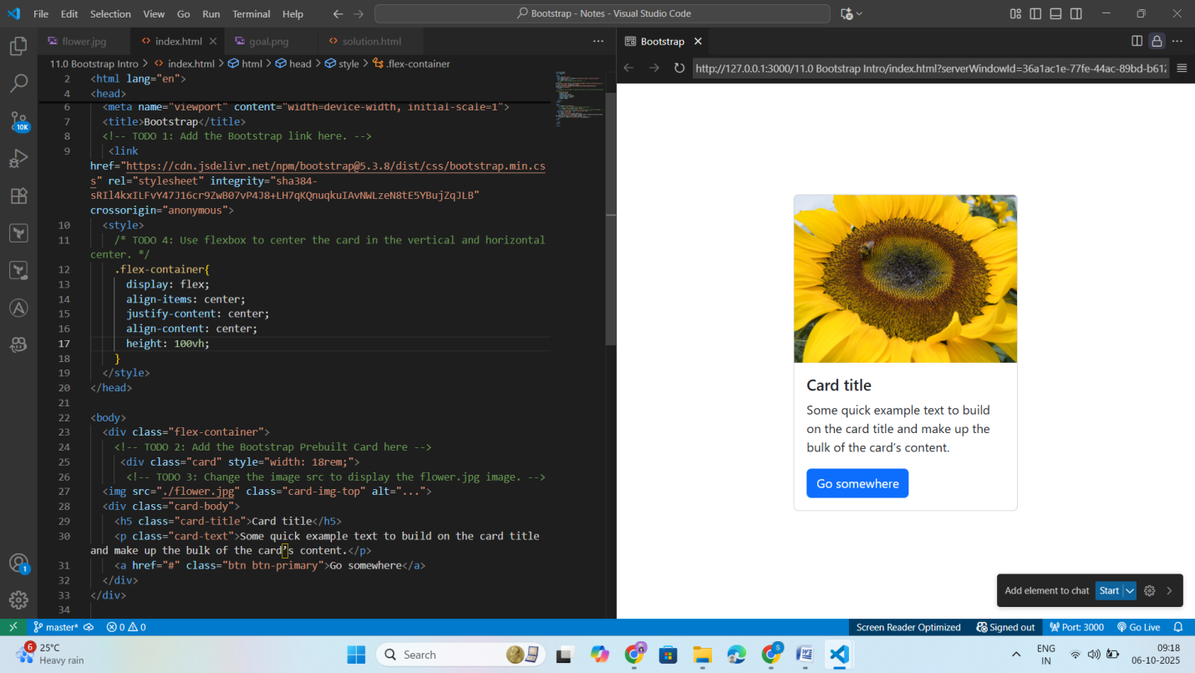

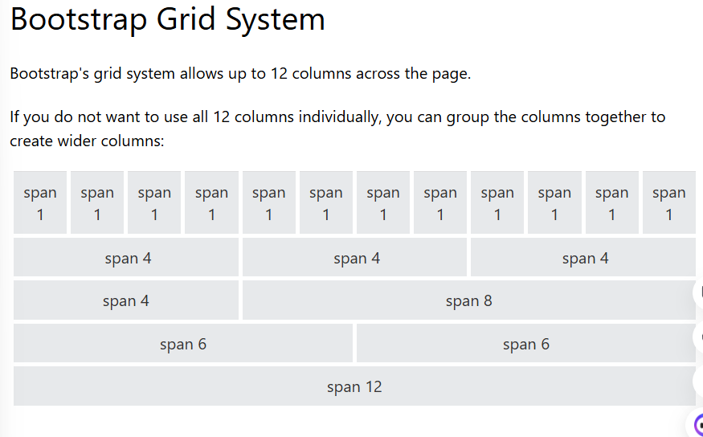

## Available breakpoints

Bootstrap includes six default breakpoints, sometimes referred to as grid tiers, for building responsively. These breakpoints can be customized if you’re using our source Sass files.

| **Breakpoint** | **Class infix** | **Dimensions** |
| --- | --- | --- |
| Extra small | None | <576px |
| Small | sm | ≥576px |
| Medium | md | ≥768px |
| Large | lg | ≥992px |
| Extra large | xl | ≥1200px |
| Extra extra large | xxl | ≥1400px |

Grid Classes

The Bootstrap grid system has four classes:

* xs (for phones - screens less than 768px wide)
* sm (for tablets - screens equal to or greater than 768px wide)
* md (for small laptops - screens equal to or greater than 992px wide)
* lg (for laptops and desktops - screens equal to or greater than 1200px wide)

The classes above can be combined to create more dynamic and flexible layouts.

**Bootstrap Layout**

<https://appbrewery.github.io/bootstrap-layout/>

Both are same

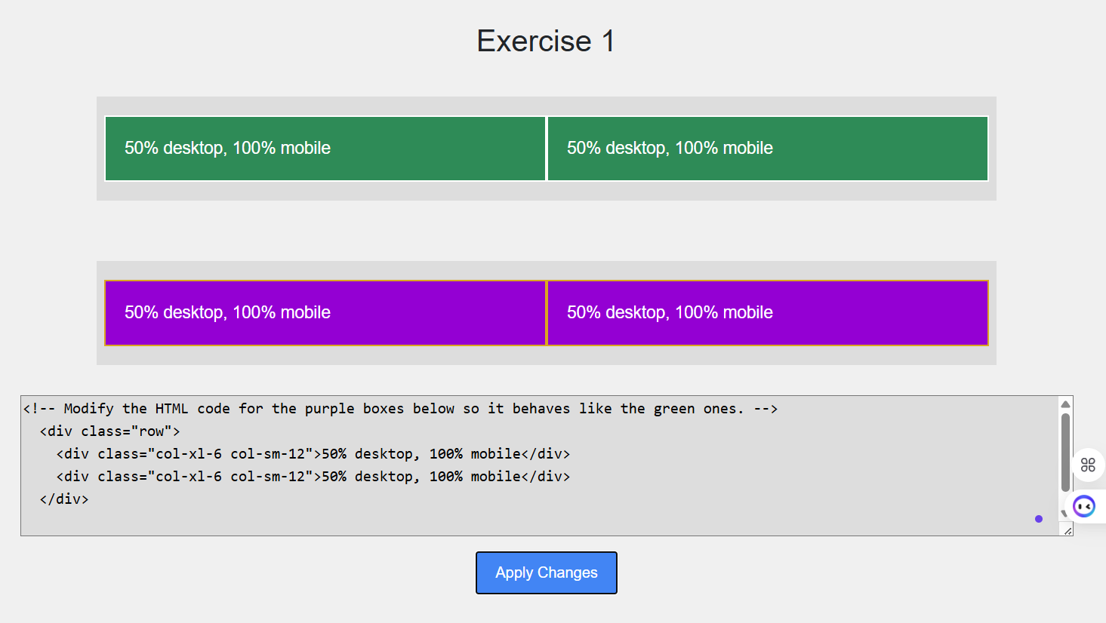

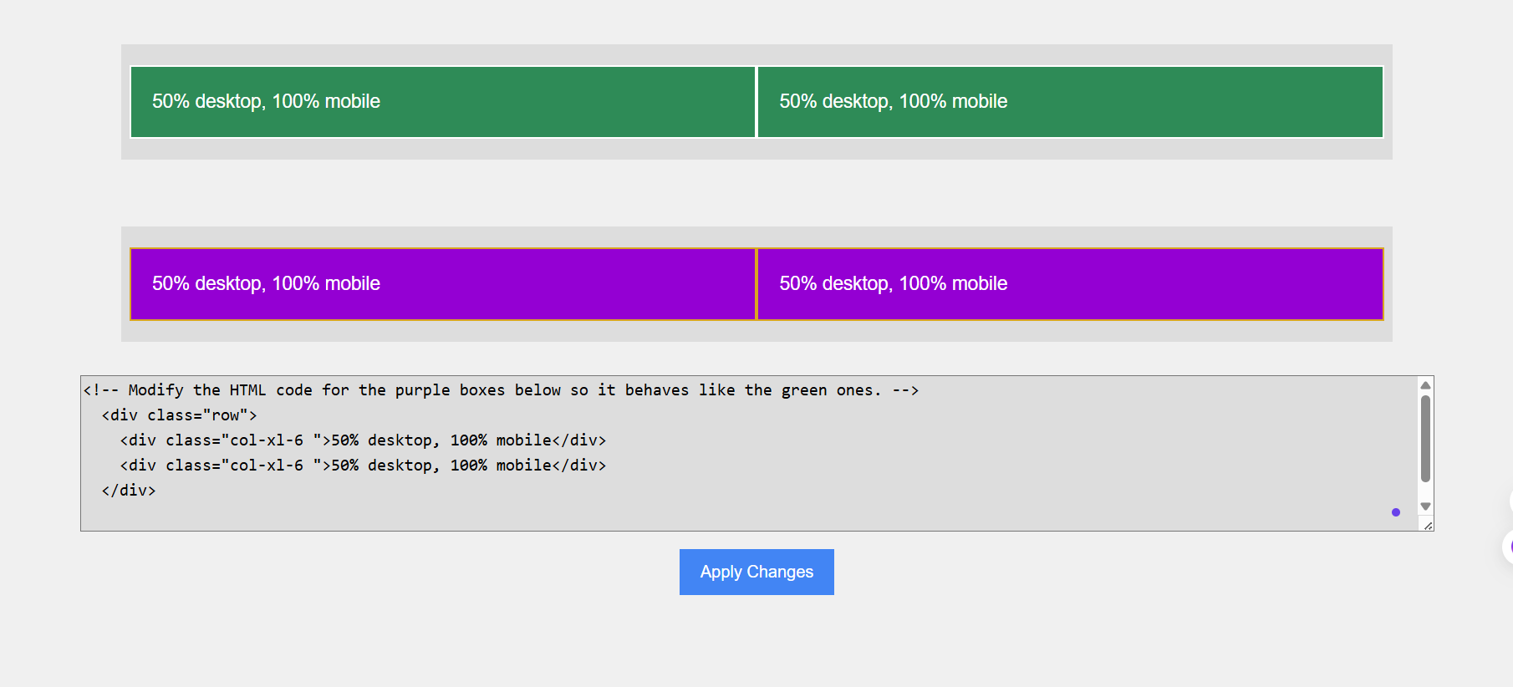

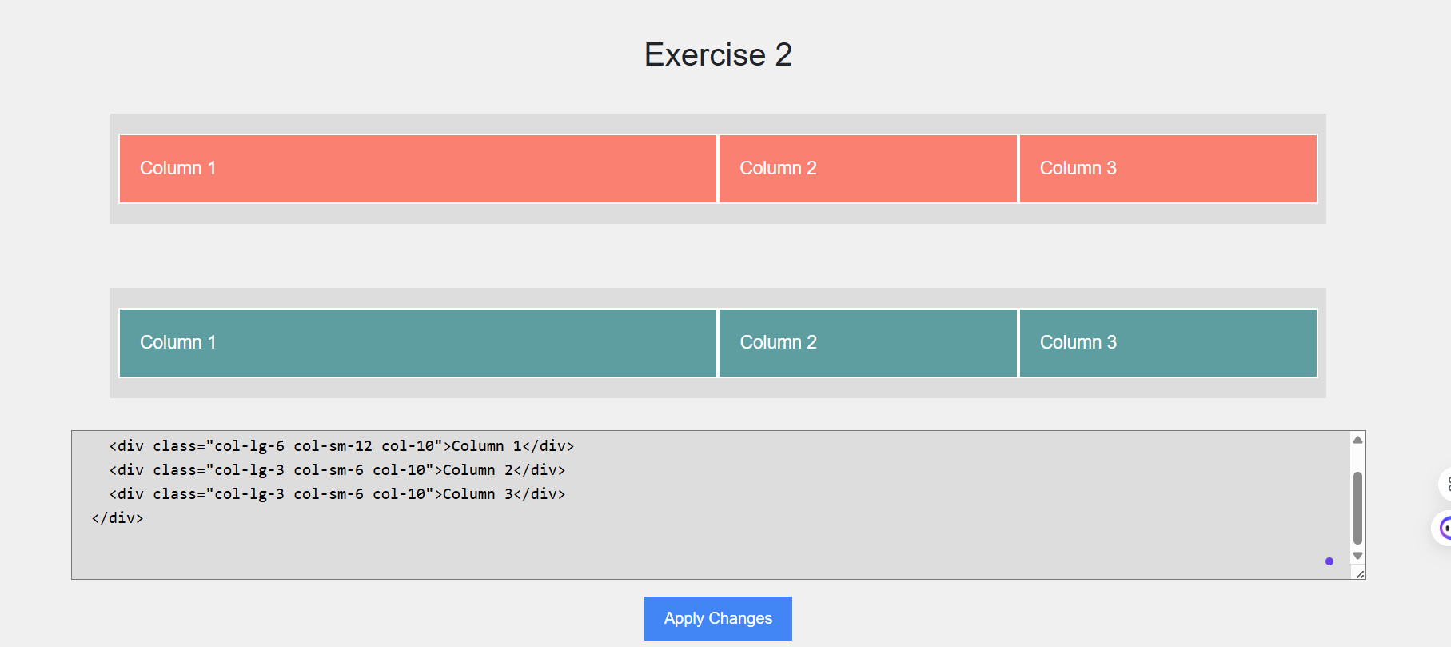

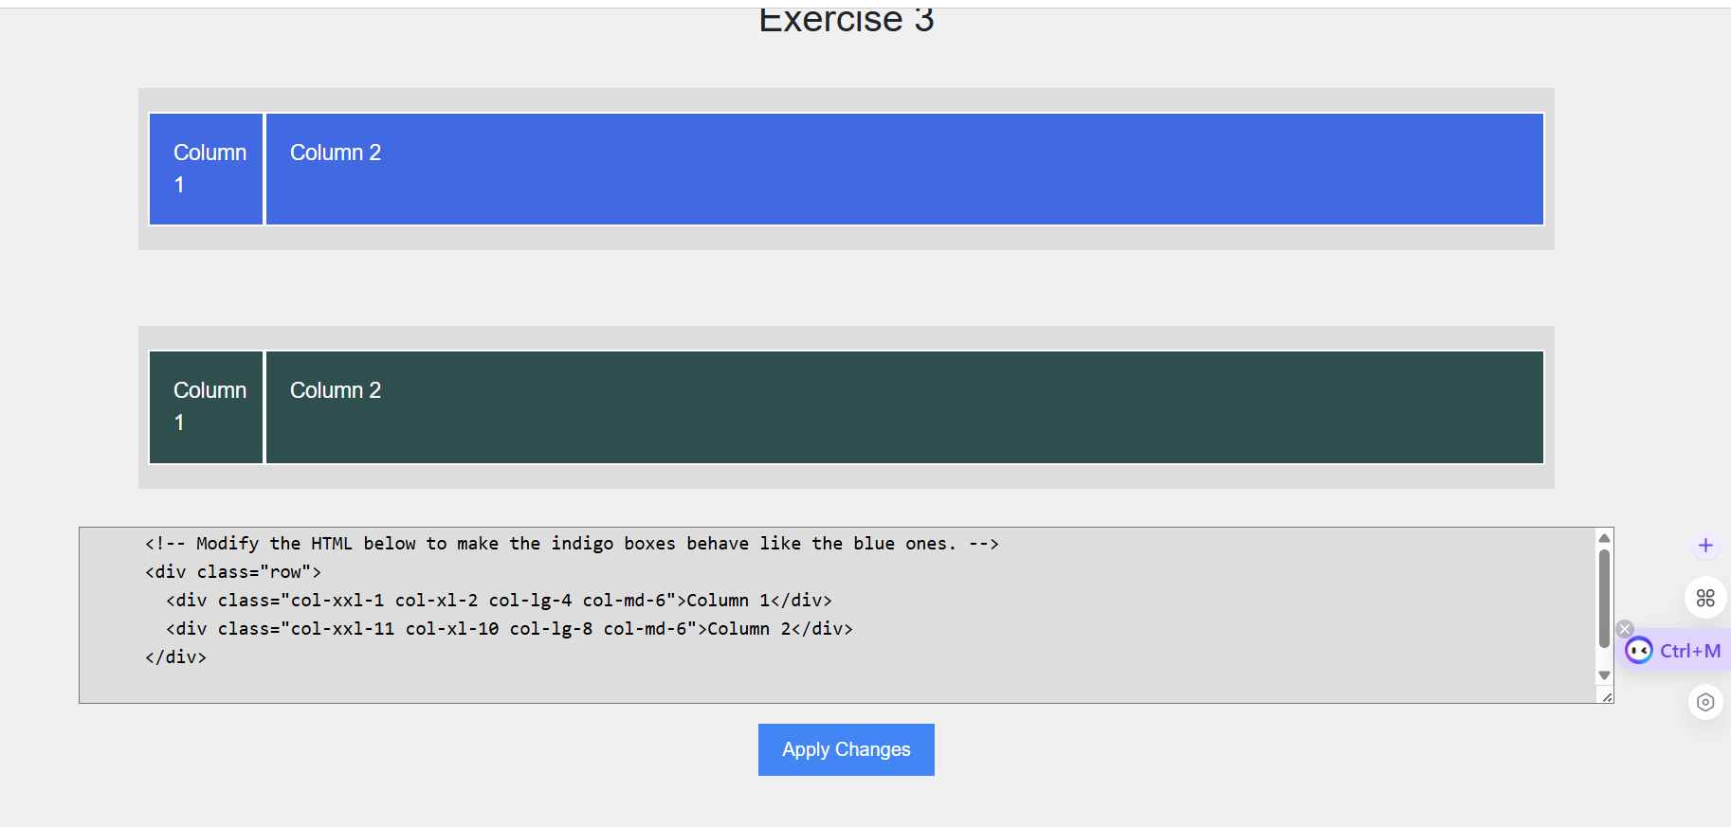

**Bootstrap Components**

Bootstrap buttons

Container-for layout

Carousel-for page

Snippets -for footer section

<https://getbootstrap.com/>

<https://getbootstrap.com/docs/5.3/examples/>

<https://getbootstrap.com/docs/5.3/getting-started/introduction/>

Bootstrap Project

<https://appbrewery.github.io/tindog/>